**FABER – GILBERT CUPS**

**1968-2024**

Wales entered the first ever Faber Cup competition in 1968. Up until that time the Glorney Cup had been exclusively for boys so this new tournament allowed the girls the same international type of event. A trophy was presented by Faber books. The only difference in format was that the girls’ event was over fewer boards.

Initially the Faber Cup was held alongside the British Championships but in 1976 it was, for the first time, held together with the Glorney Cup tournament.

In 2009 the Faber Cup became the Gilbert Cup. Jessica Gilbert was a very talented English chess player who died at the age of 19, and the trophy was presented in her memory.

No Welsh team was entered 1970-1975, 2005, 2011, 2012 and 2022.

List of those who have represented Wales together with their club or town of origin:

Lorna Allix 2006, 2008 Buckley

Khushi Bagga 2023 Cardiff

Bethan Bateman 1987 Glanmor

Suzie G. Blackburn 1999, 2000, 2003, 2004 Grappenhall

Brenda Blake 1968 Merthyr

Imogen A. L. Camp 2015, 2016 , 2017 Colwyn Bay

Yvonne Coates 1980, 1981, 1982, 1983, 1985 Neath

Eleanor Collins 1994, 1995 Morriston

Patricia Cook 1995 Bow Street

Ruth Cordy 1990, 1994 Caerphilly

Catherine M. Davies 1968 Brecon

Clare Davies 1986, 1988, 1989 Cardiff

Lauren Davies 2009 Bridgend

Sian Davies 1996, 1997 Stoke

Stephanie Du Toit 2013, 2014 Monmouth

Abigail Dyce 1991, 1992, 1994, 1995, 1996 Annesley

Deborah Evans 1976, 1977, 1978, 1979 Kenilworth

Jacqui Forrest-Jones 1968, 1969 Pontypool

Suzanne Foster 1968 Talybont

Susanna Fraser 2017, 2018, 2019, 2020, 2021 North Cardiff

Donna Furmage 1988, 1990, 1991, 1992, 1993 Cefn Fforest

Sharon Furmage 1989, 1993 Cefn Fforest

Helen Gale 1998 Cardiff

Jane Garwell 1976, 1977, 1978, 1979 Pontypool

Neya Govindaraj 2017(B) North Cardiff

Dawn M. Griffiths 1983, 1984 Caerphilly

Katherine Griffiths 1988, 1991, 1992 Abercynon

Rhiannon Hammond 1998, 1999. 2000 Neath

Lindsay Jackson 1989 Pembroke

Diana James 1980, 1981 Cardigan

Gaynor D. James 1976, 1977, 1978, 1979, 1980, 1981, 1982 Pontypridd

Catherine A. Jenkins 1969 Chepstow

Amanda John 1996, 1997 Bishop Vaughan

Lowri Johnston 2000 (combined team) , 2001, 2002, 2003 Carmarthen

Nyala Kalavala 2017 (B) North Cardiff

Emma Kong 2023, 2024 Cardiff

Beverly Lewis 1976 Bridgend

Francesca Lloyd 2007 Flint

Eva Los 2007, 2010, 2012 Upper Killay

Aishwarya Lutchman Singh 2017 Barry

Raga Mandadupu 2024 Cardiff

Rachel McIntosh 2017, 2018, 2019 Chepstow

Angharad Mortimer 1989, 1990, 1993 Cefn Fforest

Megan Owens 2006, 2007, 2008, 2009, 2010, 2012, 2013 Monmouth

Ann Powell 1997, 1998, 1999, 2000,2001, 2002 Swansea Valley

Lynda Powell 1982, 1983, 1984, 1985, 1986, 1987 Newport

Hiya Ray 2021 Cardiff

Elizabeth Rees 1981 Neath

Sioned Rees 2004, 2006, 2008, 2009 Caerphilly

Megan Richards 2015 Cardiff

Tabitha Ryan 2021 Merthyr

Ashika Shahameeran 2023 Cardiff

Ashwaria Singh 2017 (B) Penarth

Shayanna Sivarajasingham 2014, 2015, 2017, 2018, 2019, 2020 Cardiff

Venetia Sivarajasingham 2014, 2016, 2020 Cardiff

Olivia Smith 2000, 2001, 2002, 2003, 2004 Cardiff

Ann Spiller 1985, 1986, 1987, 1988 Bristol

Beth Spiller 1984, 1985, 1986, 1987 Bristol

Katie Treharne 2010 Bridgend

Elizabeth Tudor 1969 Merthyr

Bronwen Tuson 2024 Aberystwyth

Helen Veale 1983, 1984 Swansea

Alyssa Wang 2012, 2013, 2016 Cardiff

H. Claire Watkins 1977, 1978, 1979, 1980, 1982 Pennard

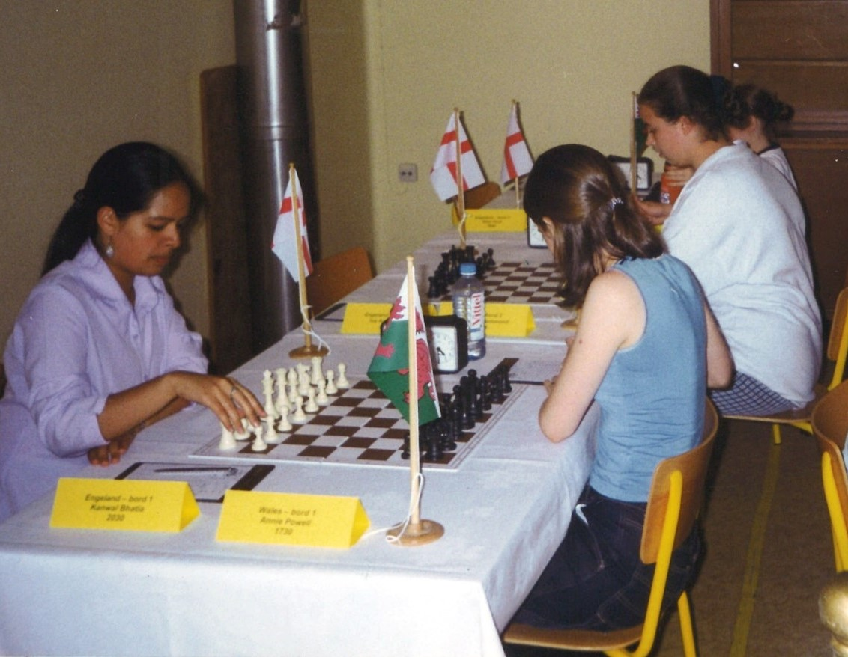

1999 and Wales are ready for battle with England. Nearest to camera on the right is Annie Powell, then Rhiannon Hammond and Suzie Blackburn